Lab 44-1 Defining Assignment Rules for Sales Data
Goals | To create an assignment rule group and assignment rules for assigning the previously imported accounts.
Scenario | You have imported existing account data and now want to assign positions to the accounts.
Time | 20 minutes
Instructions:
- If necessary, log in to Siebel Call Center as SADMIN using the Siebel Web Client.
- Verify you have the correct positions since you will be using these in your assignment rules.
  - Select Administration - User > Employees.
  - Verify the employees and their positions match the screenshot below:
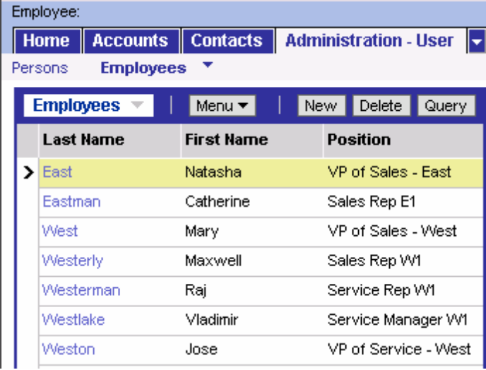
- Create an assignment rule group.
  - Navigate to Administration - Assignment > Rule Groups List.
  - Create a new rule group and name it Sales Rule Group.
- Create an assignment rule.
  - Drill down on Sales Rule Group to navigate to the Assignment Rules list applet for this group.
  - Create a new assignment rule with the following values:
Name | US Sales West
Object | Account

  - Drill down on US Sales West to navigate to the Assignment Rule form applet.
  - In the Criteria list applet, add criteria to include only that looks for the location of the account based on state:
Rule Criterion | Account State
Person Candidates Source | From Rule
Comparison Method | Compare to Object
Inclusion | Include
Required | Always

  - In the Values list applet below the Criteria list applet, add a record for each of four western US states, CA, OR, NV, AZ, using the following abbreviations and leaving the Score field blank:
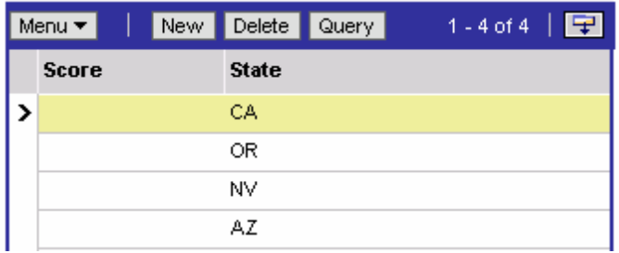

  - Define positions as possible candidates for assignment.
    - Scroll back up and click the Position Candidates tab to create the following records:
Position | VP of Sales – West
Position | Sales Rep W1
- Activate the rule.
  - Navigate to the Rules List using the hyperlink.
  - Click the Release button to activate the rule and click OK. The assignment rule is now ready to be used.
- Describe what this assignment rule will do.
- In the remainder of this lab, you will use Batch Assignment to test the rule you created. First, verify the Assignment Manger server component is online.
  - Navigate to Administration - Server Management > Components.
  - Verify the Component State for Assignment Manager is Online.
Note: If the Assignment Manager component is not online, verify that the Assignment Manager component group is enabled on your Siebel Server. You can also restart the Siebel Server service. For more assistance, please ask your instructor.
- Enable event logging as an aid for debugging your assignment rules.
  - Select Administration - Server Configuration > Servers
  - In the Components list applet, select the Batch Assignment component.
  - In the Events list applet, change the log level for Object Assignment and Rules Evaluation to 4.
Remember that in the Data Loads section of this course, you imported four account records into the database. In view such as My Accounts or All Accounts, these account records are not visible until a position has been assigned. In this batch assignment, the rule you just created will assign these account records.
- Start a Batch Assignment server task.
  - Navigate to Administration - Server Management > Jobs.
  - In the Jobs list, click New.
  - In the Component/Job field, select Batch Assignment.
  - In the Job Parameters list, create the following record:
Name | Value
Assignment Object Name | Account
  - Start the Job.
Note: This may take several minutes to complete. Refresh the query to monitor job status.
- Read through the information in the Tasks view.
  - Which accounts passed the rule criteria?
- Select Accounts > Account List.
  - Do any of the accounts appear in the My Accounts view? Why?
- Inspect the log files.
  - Navigate to C:\SUsea\siebsrvr\log. Open the Batch Assignment log file that was just created in response to you starting the batch assignment server task. The name of the file is similar to ASGNBatch_XXXX.log.
- Inspect the various steps taken during the evaluation and assignment process, and review where your rule passed and where it failed. Notice that the same information is available in this log file.
Lab 44-2 Defining Employee Skills
Goals | To create employee skills for service representatives.
Scenario | You want to create employee skills for your service representatives so that the most qualified representative will be assigned. This should be done before creating the service request assignment rule.
Outcome | Defined skills for employees.
Time | 15 minutes
Instructions:
- If necessary, log in to Siebel Call Center as SADMIN using the Siebel Web Client.
- For this lab and the lab for the following module, you will need to add some product information. Select Administration - Product > Product Lines.
  - Create three new product lines with the following values:
Product Line | Printer
Product Line | Fax and Copiers
Product Line | Office Supplies
  - Click Products in the link bar to associate the products that were imported previously with product lines you just created:
Product | Product Line
Collation Tray | Fax and Copiers
Fax Machine | Fax and Copiers
Network Printer | Printer
Shredder | Office Supplies
Toner Cartridge | Office Supplies
- Add skills to an employee for the assignment rule.
  - Navigate to Administration - User > Employees > Assignment Skills.
  - Select employee Raj Westerman.
  - Create a new Assignment Skills record:
Skill | Product Line
  - In the Employee Skill Items list, create a new record with the following values:
Product Line | Office Supplies
Expertise | Expert
  - Select employee Vladimir Westlake.
  - Create a new Assignment Skills record:
Skill | Product Line
  - In the Employee Skill Items list, create a new record with the following values:
Product Line | Fax and Copiers
Expertise | Intermediate
- Create a rule to assign any service requests related to the Office Supplies product line to the employee with the appropriate skill set.
  - Navigate to the Assignment Rule Groups list applet and create an assignment rule group named Service Rule Group.
  - Drill down on Service Rule Group to navigate to the Assignment Rules list applet.
  - Create a new assignment rule with the following values:
Name | Service Request by Product Line
Object to be Assigned | Service Request
Person Candidates Source | All People
- Drill down on Service Request by Product Line to navigate to the Assignment Rule form applet.
- In the Criteria list applet, add product criteria to the Service Request by Product Line rule using the following values:
Criteria | Product Line
Comparison Method | Compare Object to Person
Inclusion | Include
Required | Always
Note: Compare Object to Person is used here to compare the object, Service Request, to attributes of person candidates, in this case, skill sets.
- Return to the Assignment Rules List.
- Click the Release button, and then click OK to activate the rule. The assignment rule is now ready to be used.
- Now test the rule using Batch Assignment.
  - Create a service request record to test that your Service Request assignment rule works correctly.
Summary | SR Shredder Test
Product | Shredder

  - Notice that for the Service Request you just created, the record has no owner.
  - Refer to the instructions in the previous lab to create the Batch Assignment job. Be sure to set the Assignment Object to Service Request rather than Account.
  - Once the job has completed, read through the information in the Tasks view.
  - This rule evaluated All People. To which candidate was the object assigned? Why?
- Inspect the log files.
  - Navigate to C:\SUsea\siebsrvr\log. Open the Batch Assignment log file that was just created in response to you starting the batch assignment server task. The name of the file is similar to ASGNBatch_XXXX.log.
- Inspect the various steps taken during the evaluation and assignment process, and review where your rule passed and where it failed.

